**Working with Constraints**

Constraints limit or control the types of data that the user can enter into your tables. There are

seven main categories of constraints. They include primary key constraints, foreign key constraints,

default constraints, not null constraints, check constraints, rules, and unique constraints. The text

that follows covers each of these constraint types in detail.

**Primary Key Constraints**

A primary key constraint is a column or a set of columns that uniquely identify a row in the table.

Although you can designate more than one field as the primary key, each table can have only one

primary key.

Every table in your database should have a primary key constraint. Furthermore, it is best if your

primary key meets the following criteria:

Short

Stable

Simple

*Short* means that it should be composed of as few fields as possible and the smaller the field type

is, the better. In fact, the optimal primary key is a single int field. *Stable* means that the data

within the field never changes. A great candidate for a primary key is an identity column. The

"Identity Columns" section of this hour covers identity columns in detail. *Simple* means that it is

easy to remember and deal with. For example, an int field is simple, whereas a char field

containing a long string of complex characters is not.

To add a primary key to a table, follow these steps:

**1.** Use the gray selectors on the left side of the Table Designer to select the fields that compose

the primary key (see Figure 4.2).

**Figure 4.2. Use the gray selectors on the left side of the Table**

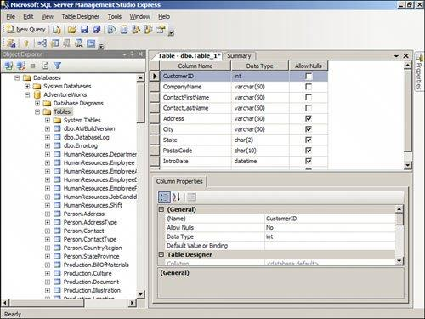**Designer to select the fields that compose the primary key.**

**2.** Click the Set Primary Key tool on the toolbar. The columns appear with a Key icon on the

record selector (see Figure 4.3).

**Figure 4.3. The columns included in the primary key appear with a**

**Key icon on the record selector.**

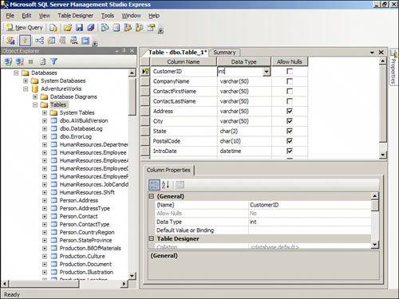

**Foreign Key Constraints**

A foreign key constraint consists of a column or of a set of columns that participates in a

relationship with a primary key table. The primary key is on the *one side* of the relationship,

whereas the foreign key is on the *many side* of the relationship. A table can have only one primary

key, but it can have multiple foreign keys. Each foreign key relates to a different primary key in a

separate table. SQL Server looks up the foreign key value in the primary key table to ensure that

only valid data is included in the table. Hour 5, "Working with Table Relationships," covers foreign

key constraints in additional detail.

**Default Constraints**

A default constraint is a value that SQL Server automatically places in a particular field in a table. A

default value can be a constant, Null, or a function. All fields except identity and time stamp fields

can contain default values. Each column can have one default constraint. You enter the default

constraint in the properties for the desired field (see Figure 4.4).

**Figure 4.4. You enter the default constraint in the properties for the**

**desired field.**

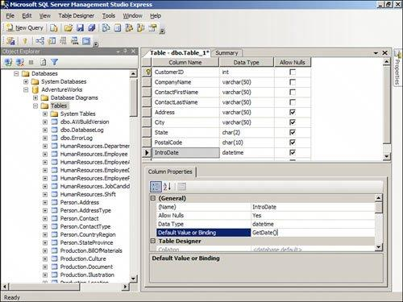

**Table 4.2. Examples of Default Constraints**

**Expression**

GeTDate()

Null

7

'Hello'

**Result**

Sets the default value to the current

date

Sets the default value to Null

Sets the default value to the number 7

Sets the default value to the string

"Hello"

**Not Null Constraints**

In certain situations, you may want to require the user to enter data into a field. The Not Null

constraint enables you to accomplish this task. To set a Not Null constraint, ensure that you

uncheck the Allow Nulls check box (see Figure 4.5).

**Figure 4.5. To set a Not Null constraint, ensure that the Allow Nulls check box is unchecked.**

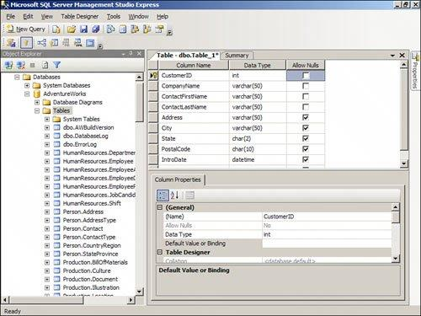

**Check Constraints**

Check constraints limit the range of values that a user can enter into a column. You can enter as

many check constraints as you want for a particular column. SQL Server evaluates the check

constraints in the order in which you entered them. To enter a check constraint, follow these steps:

**1.** Click the Manage Check Constraints tool on the toolbar. The Check Constraints dialog box

appears.

**2.** Click Add to add a new constraint.

**3.** Provide a constraint name and a constraint expression.

**4.** Designate other options as necessary. The completed dialog appears as in Figure 4.6.

**5.** Click Close to close the dialog box and add the constraint.

**Figure 4.6. The Properties dialog box enables you to enter Check**

**constraints for the table.**

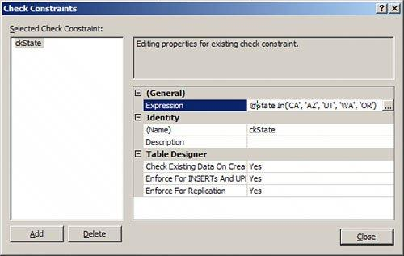

Whereas Check constraints apply only to the table for which you enter them, you can apply rules to multiple tables. Microsoft is phasing out support for rules. You are therefore not allowed to create new rules. Instead of using rules, you should use check constraints and triggers.

UNIQUE Constraints

A UNIQUE constraints enforces the uniqueness of values in a set of columns, so no duplicate values are entered. The unique key constraints are used to enforce entity integrity as the primary key constraints